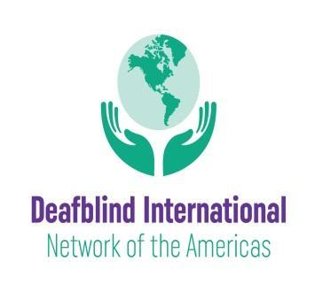 September 17, 2021
Greetings!
We wanted to share exciting news about a newly revitalized network within Deafblind International—the Network of the Americas. The mission of this network is to provide opportunities and platforms where members can share their successes, challenges and practices toward creating a barrier-free life for people who are deafblind. There are three ways to engage in this network: 1) become a member of Deafblind International (membership is free); 2) become a member of the DbI Network of the Americas (also free); and 3) if you use Facebook, consider joining our Facebook Group.
Deafblind International, in an effort to remove barriers to participation, has decided to offer free individual memberships. We hope that many members of the national deafblind networks in the United States, Latin America, the Caribbean, and Canada will join this international organization that offers access to information, the online magazine DbI Review, and regional and international conferences. If you are not yet a member, please register for DBI membership here.
If you would like to become a member of the Network of the Americas and receive future communication, kindly complete our membership form: DbI Network Membership.
The Network of the Americas has convened a small leadership group whose goal is the development of a plan to provide our members across the United States, Latin America, the Caribbean and Canada with an opportunity to learn from one another in a meaningful way. With the hope of better understanding the needs within our region, we invite you to connect with us through our Facebook group, where you can offer your insights and also find information on resources, training and conferences.
We are also happy to share news about the recent successful partnership for the 2021 Texas Symposium on Deafblind Education, between the Texas School for the Blind and Visually impaired (TSBVI), DbI Network of the Americas, and the National Family Association for Deaf-Blind (NAFDB). With over 1,000 professionals and family members from around the world having participated, lifelong learning and connections were made that we hope will propel us into our next exciting chapter.
We hope that you will join us as we continue to build our community. Thank you in advance for your interest and support.
With all good wishes during these challenging times.
The Leadership Team of the Deafblind International Network of the Americas

